

-------------------------------------------------------------------------------------------------------------------------------
High Level Design Document
Prepared by: Mark Kelly
daa
Azure API Management Proof of Concept

---------------------------------------------------------------------------------------------------------------------------------------------

Contents

1. Introduction 4
1.1. Document Overview 4
1.2. PoC Objectives 4

---2. APIM Architecutre 5
2.1. As-Is API Journey 5
2.2. PoC API Journey 6
2.3. PoC Design Decisions 7
2.4. Market Place APIs 7
2.5. Strategic View: Multi-environment Logical Architecture 8
2.6. Strategic View: Consolidated Non-Production Gateway 8
2.7. Strategic View: APIM’s built-in Gateway 9
2.8. Strategic View: Multi-environment Ingress Architecture 10

3. APIM Tiers 12
3.1.1. APIM Classic Tiers 12
3.1.2. APIM v2 tiers 13

4. APIM Features 14
4.1. APIM APIs 14
4.2. APIM Products 14
4.3. APIM Workspaces 14
4.3.1. Workspace Features 15
4.3.2. Workspace Gateways 16
4.3.3. Workspace Gateway Constraints 16
4.4. Authorization 17
4.4.1. Current Authorization Code Flow 19
4.4.2. APIM Authorization Code Flow 21
4.5. Integration Considerations 22
4.5.1. Application Gateway Integration 22
---4.5.2. Container Apps Integration 22
4.6. APIM Policy 22
4.6.1. APIM Policies 23
4.6.2. APIM Policy Example 24
4.7. IAM 25
4.8--. Virtual Network Integration 26
4.8.1. Virtual Network Injection (VNet Injection) 26
4.8.2. Virtual Network Integration (VNet Integration) 27
4.9. DNS 27
4.9.1. Public DNS 27
4.9.2. Private DNS 27
4.10. HIGH AVAILABILITY 27
4.10.1. Automatic availability zone support 28
4.10.2. Manual availability zone support 28
4.10.3. Considerations 29

5. DevOps & Operating Model 30
5.1. Terraform Providers 30
5.1.1. AzAPI Provider Example 30
5.2. RACI Matrix 31
5.3. DEPLOYMENT PATTERNS BY TEAM 32
5.3.1. Cloud Platform Team 32
5.3.2. Integrations Team 33
5.3.3. Backend Development Team 33

6. APIM Running Costs 35

7. Appendix 36
7.1. Platform requirements 36
7.2. RACI Definitions 36
7.3. Glossary of Terms 37

Version C---ontrol
Date | Version | Changed By | Reason for Change
27/11/2025 | 0.1 | Mark Kelly | Initial Draft
02/01/2026 | 0.2 | Mark Kelly | Updated based on feedback and comments
06/01/2026 | 0.3 | Mark Kelly | Updated sections  - 4.4.3 ADB2C Integration  - 4.4.4 Identity Propagation  - 4.6.2 (jwt-validation) Policy example  - 4.6.3 Key Policy Parameters
---

--Introduction

Document Overview
The purpose of this document is to provide a high-level design to inform the implementation of Azure’s API Management service (APIM) as part of a Proof of Concept allowing daa to evaluate the service’s suitability a long-term, strategic API Gateway.
Specifically, the document details the proposed architecture for integrating Market Place APIs into an APIM workspace gateway, demonstrating how these APIs can be surfaced securely.

PoC Objectives

The pr--imary objectives of this PoC exercise include:
- Demonstrate the end-to-end architecture for surfacing Market Place APIs via an APIM workspace gateway.
- Validate the API journey for both authenticated and unauthenticated users against specific Market Place APIs
- Surface the development effort required to facilitate direct connectivity between APIM APIs and Market Place backend services i.e. bypassing the Market Place BFF service
- Validate secure and private communication between the Application Gateway, APIM workspace gateway and Container App environments through Virtual Network peering
- Validate the OAuth flow by configuring APIM to perform JWT validation
- Validate the deployment of APIM workspaces to facilitate a federated API Gateway model as well as the IAM implementation to mitigate against cross domain/environment access and contamination

- Validate the release pattern for deploying APIM APIs in an automated manner e.g. by leveraging Terraform to import swagger definition(s)

- Add phase 2 details

APIM Architecutre

Current API Architecture

Network Architecture
The diagram below illustrates a high-level overview of how Market Place APIs are currently surfaced publicly.
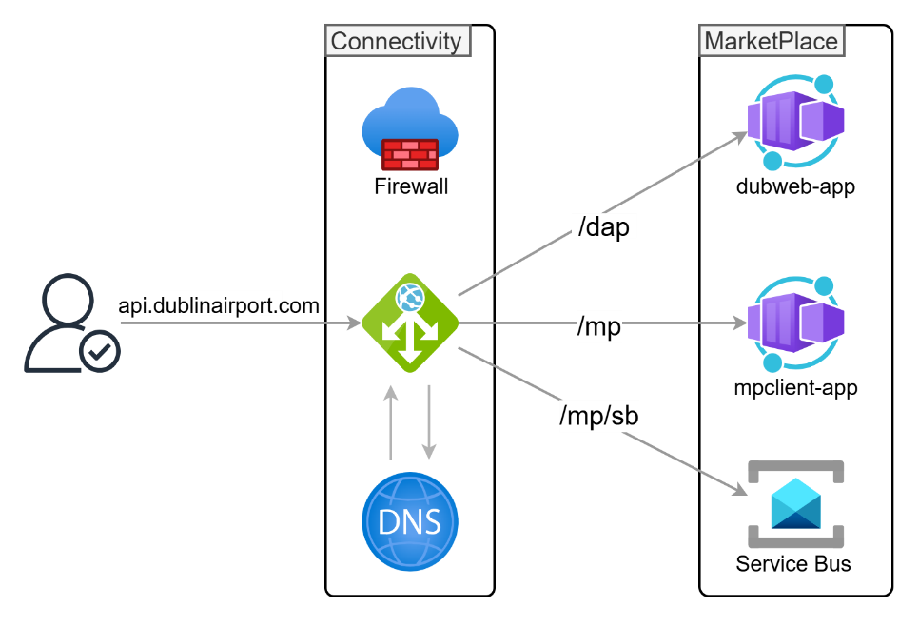
Using the Production FQDN for Market Place APIs – api.dublinairport.com – the diagram illustrates the following configuration:
- All public APIs are surfaced via a listener configured on the centralised Application Gateway hosted in the Connectivity subscription.
- The Application Gateway is configured with path-based routing such that all traffic destined for api.dublinairport.com/mp will be routed to the Market Place Client service hosted within the Azure Container Apps Production environment. Similarly, path-based rules are also in place for /dap and /mp/sb.
- Traffic between the Application Gateway and the Container App environments is routed over a Virtual Network peering connection and as such is deemed internal traffic.
- The Application Gateway will route traffic to the Container App environment’s hostname by conducting a DNS query against a private Hosted Zone, also hosted under the Connectivity Subscription. The Production hostnames for the Container Apps relevant to the routing configuration are captured in the table below.

Environment | Service | DNS
Production | Dublin Web Client | ca-dubweb-app-prod.jollysea-5ada6918.northeurope.azurecontainerapps.io
Production | Market Place Client | ca-mpclient-app-prod.jollysea-5ada6918.northeurope.azurecontainerapps.io
Production | Service Bus | sb-mp-prod-neu-001.servicebus.windows.net

AD B2C Tenants and App Registrations

The current authentication architecture leverages a Backend-for-Frontend (BFF) model to conduct (primarily) JWT validation across isolated environments (Dev, Test, and Production). To maintain environmental parity and security boundaries, separate Azure AD B2C Tenants are provisioned for each environment.

Application Registration Model
Within each environment specific tenant, client traffic is categorised using two distinct Application Registrations:
- Web Registration: Represents both the Web Frontend (Client) and its associated API resources.
- Mobile Registration: Represents both the Mobile App (Client) and its associated API resources.
Because this workload leverages a collapsed registration model (where the same identity represents both the Client and the Resource Server), the Audience (aud) claim is identical in both the ID Token and the Access Token. The value matches the unique Application (Client) ID of the respective Web or Mobile registration.

Authorization Code Flow

The frontend client (Web or Mobile) initiates an authentication challenge via the environment-specific Sign-Up/Sign-In (SUSI) User Flow. Upon successful credential verification, Azure AD B2C issues a set of JWTs (ID, Access, and Refresh) directly to the client. Since no backend resource registration exists, the Access Token’s aud claim is mapped directly to the originating Web or Mobile Application ID.
The client injects the Access Token into the Authorization: Bearer HTTP header of requests sent to the BFF service. The BFF is currently responsible for the entire cryptographic and computational overhead of validation. Once validated, the BFF processes the request and executes the necessary downstream API calls.
The diagram below illustrates the existing authorization code flow for Market Place. Note, this diagram was extracted from daa’s Azure DevOps Wiki.

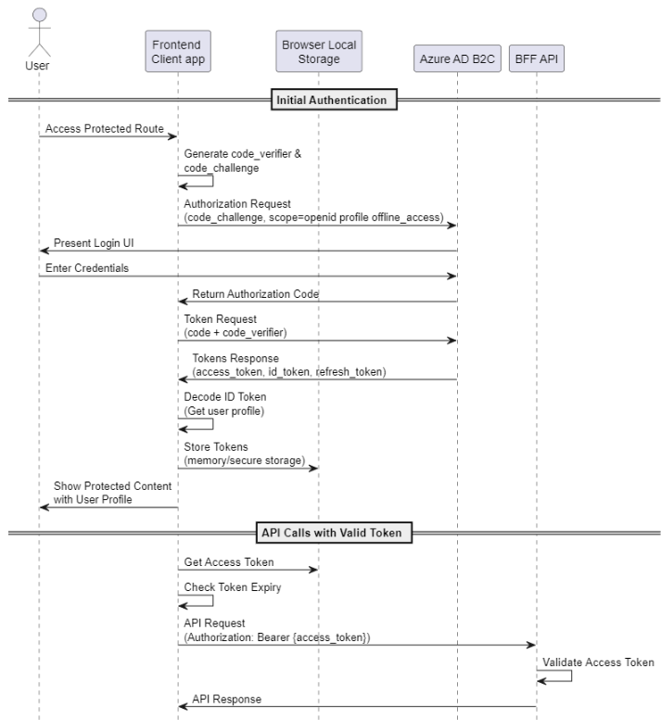

The steps below describe the current token authorization flow following a user’s successful authentication.
- Frontend retrieves access token from storage.
- Checks token expiration before making API calls.
- Includes token in Authorization header.
- BFF API validates the access token.
- Returns protected resources upon successful validation.

Architectural Components
This section describes the key architectural components to support the current user flow:
- Environment-Specific AD B2C Tenants provides isolation of user identities and policy configurations between Non-Production and Production environments.
- The backend services are configured to trust tokens issued to either the Web App Registration or the Mobile App Registration, rather than a single unified API resource.
- The validation of JWTs and signature verification is implemented within the Market Place application code, specifically on the BFF service

Target API Architecture

Architecture Overview
For the purposes of the PoC implementation, the diagram below illustrates where the APIM service and underlying workspace gateway will sit with respect to the Market Place Dev environment.

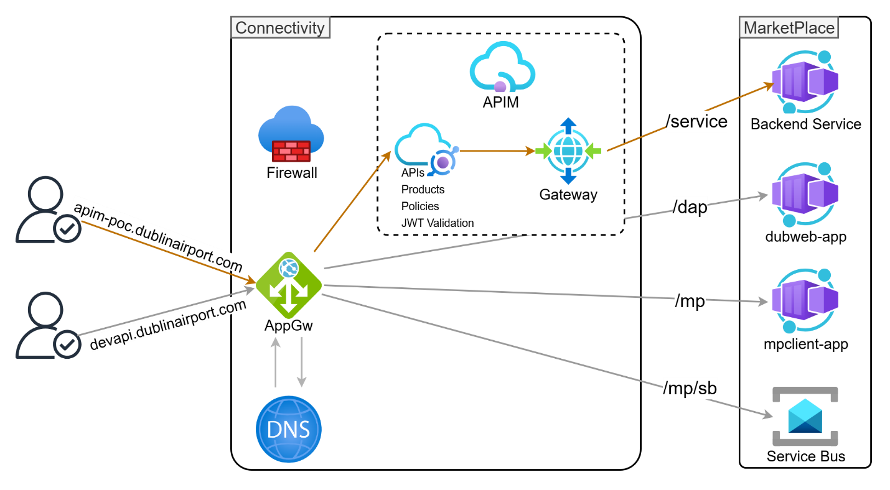

Please note the following implementation considerations:

- An individual Market Place API or small subset of Market Place APIs should earmarked for APIM integration. These APIs will be surfaced publicly via a new sub-domain e.g. apim-poc.dublinairport.com.

- The sub-domain will require a new listener and associated configuration (backend pool, routing rule, health probe etc) to be deployed to the Application Gateway. The new listener will forward all ingress traffic to the APIM workspace gateway’s runtime hostname.

- The workspace gateway’s runtime hostname follows the naming pattern: <gateway name>-<unique ID>.gateway.<Azure region>-01.azure-api.net, the exact value of which will only be known following a gateway deployment. For this reason, a new private DNS Zone (azure-api.net) will need to be created and linked to the Connectivity Virtual Network to allow the Application Gateway perform name resolution.

- Path-based routing will not be required on the PoC’s listener. All requests against the PoC sub-domain will be forwarded to the APIM workspace where specific workspace APIs will determine which backend (Azure Container Apps) API is targeted.
- All remaining Market Place APIs within the Dev environment will be deemed out of scope for this PoC and will continue to be routed via the Application Gateway’s existing sub-domain (devapi.dublinairport.com) where requests will be subject to the path-based rules configured there.

- The Market Place BFF service is hosted on the MP client and Dub Web Container services where JWT validation is conducted. Since JWT validation will be offloaded to the APIM workspace, this negates the need to integrate with the BFF service. With this in mind, the workspace gateway will forward requests directly to the Market Place backend service bypassing BFF.

PoC Design Decisions

For the purposes of this PoC, several design decisions need to be captured and agreed. These include:
- The APIM instance will be deployed to the Connectivity Subscription to align with a centralised operational model, as opposed to a distributed model where an APIM instance is deployed to individual spoke Subscriptions.
- Since the core objective of this PoC is to validate the implementation of federated workspaces, the APIM Premium Classic SKU will be deployed. At the time of writing, the APIM Premium v2 SKU is not available in Azure’s Europe North region. APIM v2 SKUs are the latest enterprise-grade tier, offering faster deployment, enhanced scalability, and simplified VNet functionality.
- When deploying an APIM Workspace Gateway configured with ‘private network access inbound and outbound’, the virtual network must be in the same region and Azure subscription as the gateway. The subnet cannot be shared with another resource and is recommended to be configured with a /24 subnet mask (252 available IP addresses). The workspace gateway will be deployed to the existing Connectivity Virtual Network.
- The APIM service will interface with the Market Place Dev environment only.
- The APIM workspace gateway will not be leveraged to facilitate service to service communication within an Container App environment.

Market Place APIs

For the purposes of this PoC, the APIM implementation will target a subset of Market Place APIs hosted within the Dev environment. The table below captures the in-scope Market Place APIs for this implementation.

Environment | API | cUrl | Authentication
dev | getUserBookings | curl --location 'https://ca-product-svc-dev.wonderfulhill-53282784.northeurope.azurecontainerapps.io/api/v1/getUserBookings' \  --header 'Authorization: ••••••' | User b2c Access token
dev | fetchParkingAvailability | curl --location 'https://ca-product-svc-dev.wonderfulhill-53282784.northeurope.azurecontainerapps.io/api/v1/fetchParkingAvailability' \  --header 'Accept: application/json' \  --header 'Content-Type: application/json' \  --data '{  "arrivalDateTime": "2026-03-10T13:10:00Z",  "returnDateTime": "2026-03-13T09:37:00Z",  "terminal": "2",  "fetchParkingForAncillary": false  }' | Public / client-credentials token

Strategic View: Multi-environment Logical Architecture

While designing a strategic implementation of APIM is out-of-scope for this PoC, it’s worth considering the longer-term approach for a full-scale deployment across multiple environments. A multi-environment approach, scoped to the Market Place product only, is illustrated below.

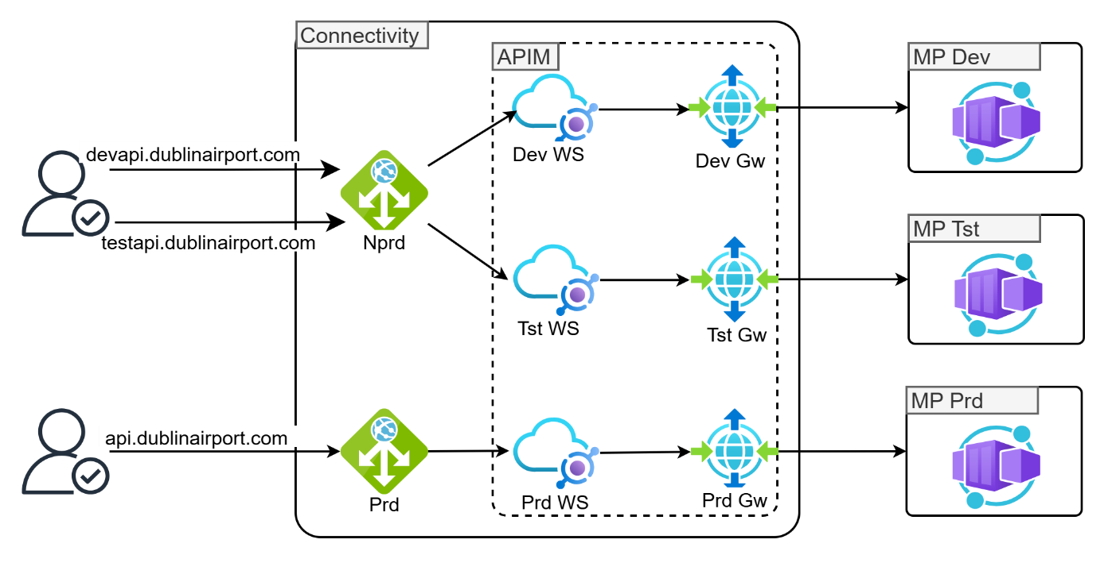
Please note the following considerations with respect to the architecture above:
- All non-production API requests against the Market Place Dev and Test environments will target the existing non-production Application Gateway. From here, traffic will be routed to environment specific workspaces e.g. Market Place Dev Workspace, Market Place Test workspace.

- Similarly, production API requests serviced by the api.dublinairport.com FQDN, will be routed to a dedicated Market Place Production workspace.

Strategic View: Consolidated Non-Production Gateway

Given the cost associated with each instance of an APIM Workspace Gateway, it’s worth considering a consolidated approach where non-production environments leverage a single, shared gateway. With this approach (illustrated below) an environment specific workspace is maintained but the underlying compute for both Dev and Test environments are shared across a common gateway. This approach aligns with the pattern currently in place for Application Gateways.
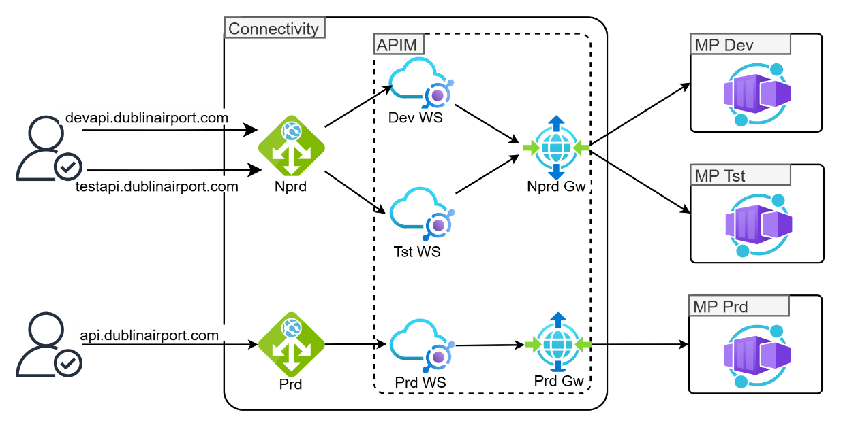

Please note the following considerations with this approach

- All APIs in both Dev and Test will share the same CPU and Memory. If a developer runs a heavy load test in Dev, it could impact the stability of the Test environment.

- By default, all workspaces on the generic non-production gateway will share the same gateway hostname (e.g., nonprod-gateway-123.gateway.northeurope.azure-api.net). We will need to differentiate the Dev and Test APIs by using a URL suffix for example /dev/bookings and /test/bookings.

Strategic View: APIM’s built-in Gateway
A further method of achieving cost savings is to leverage APIM’s default built-in gateway for non-production workspaces. As noted in the Running Costs section below, there is no official guidance on associating APIM’s default built-in gateway with a workspace. While a workspace cannot be created in the Azure portal without associating it with a workspace gateway, a standalone workspace can be created programmatically (via the API or IaC) without having to associate a workspace gateway.
Assuming running costs are a primary driver for the strategic architecture, if APIM’s default built-in gateway can be associated with a workspace, it potentially negates the need to deploy a dedicated Dev/Test workspace gateway allowing daa to reduce the overall monthly spend.
The diagram below illustrates this architecture.

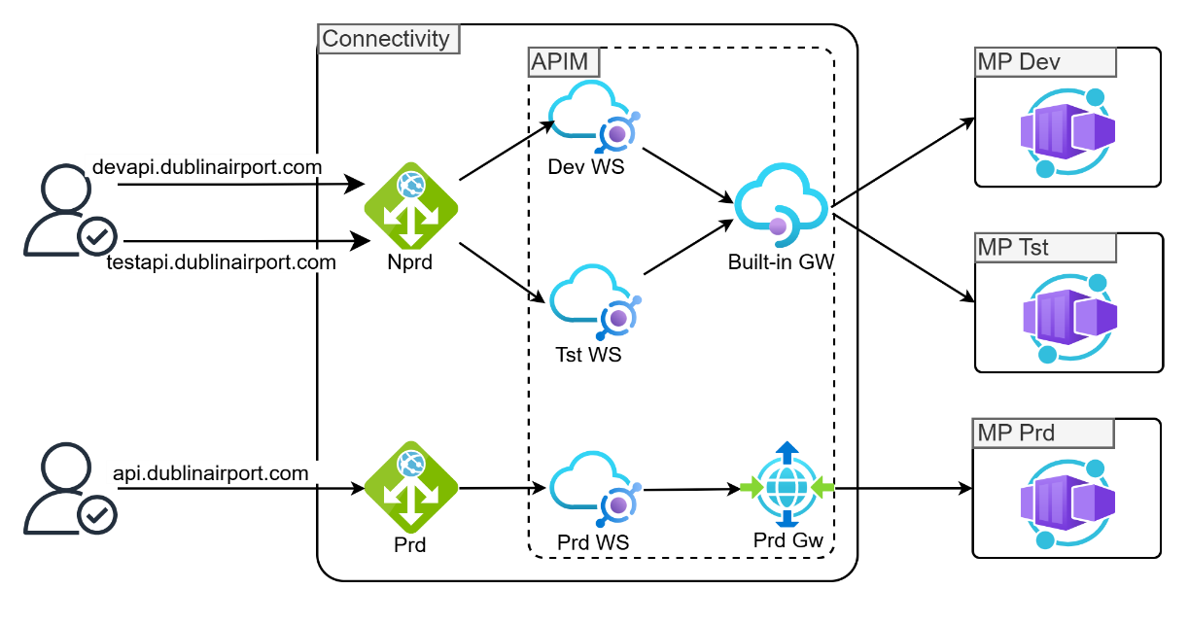
With this approach, it’s important to appreciate the following considerations with respect to the shared built-in gateway
- Because all non-production workspaces share the same compute resources, a high-load test in the Dev workspace can throttle or impact the Test workspace.

- If the unit capacity of the APIM tier is breached, it affects all workspaces simultaneously.

- Since all non-production environments share the same base URL (provided by APIM), every API in every workspace must have a unique URL suffix. For example, ‘/orders’ in Dev will conflict with ‘/orders’ in the Test environment. However, this same constraint will exist if a shared workspace gateway is associated with one or more environments.

- While workspaces provide logical isolation, a global policy or a platform-level configuration change on the parent APIM service will affect all hosted workspaces at once.

Strategic View: Multi-environment Ingress Architecture

The diagram below illustrates a multi-environment implementation approach from a networking perspective.

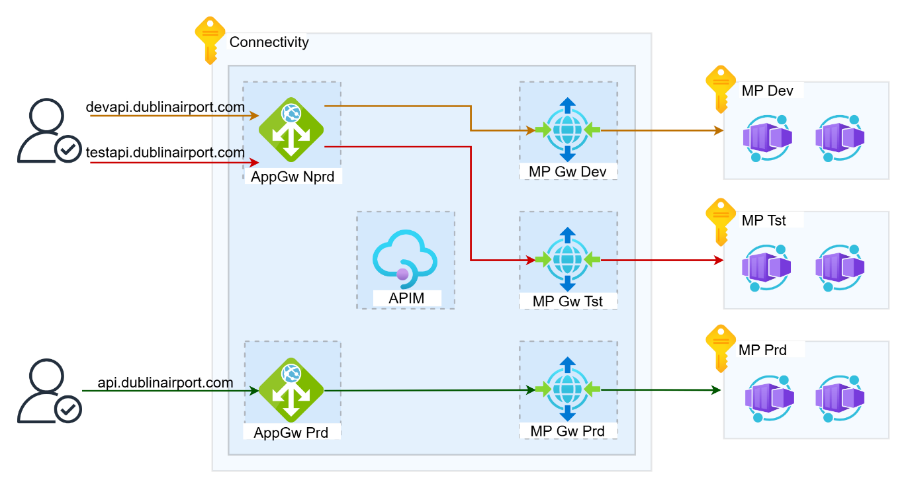

Please note the following considerations:
- A dedicated subnet is required to host the APIM service itself.
- Similarly, a dedicated subnet is required to host each workspace gateway.

APIM Tiers
Please note the features highlighted in yellow, specifically Workspaces and Self-hosted.

APIM Classic Tiers

 | Consumption | Developer | Basic | Standard | Premium | Isolated*
Purpose | Lightweight and serverless version of API Management service, billed per execution | Non-production use cases and evaluations | Entry-level production use cases | Medium-volume production use cases | High-volume or enterprise production use cases | Enterprise production use cases requiring high degree of isolation
Cache (per unit) | External only | 10 MB | 50 MB | 1 GB | 5 GB | 5 GB
Scale-out (units) | N/A (automatic scaling) | 1 | 2 | 4 | 12 per region  (call support to add more) | 12 per region  (call support to add more)
SLA | 99.95% | No | 99.95% | 99.95% | 99.99%1 | 99.99%
Isolation | Shared | Private | Private | Private | Private | Private
Usage limits | Limits apply | No | No | No | No | No
Cache, external3 | Yes | Yes | Yes | Yes | Yes | Yes
Developer portal | No | Yes | Yes | Yes | Yes | Yes
Multiple custom domain names4 | No | Yes | No | No | Yes | Yes
Azure Active Directory integration in developer portal | No | Yes | No | Yes | Yes | Yes
Availability Zone support | No | No | No | No | Yes | No
Virtual Network support | No | Yes | No | No | Yes | Yes
Multi-region deployment | No | No | No | No | Yes | Yes
Self-hosted gateway | No | Yes | No | No | Yes | Yes
Workspaces | No | No | No | No | Yes | No
Estimated maximum throughput2  (per unit) | N/A (automatic scaling) | 500 requests/sec | 1,000 requests/sec | 2,500 requests/sec | 4,000 requests/sec | 4,000 requests/sec
Compute isolation | No | No | No | No | No | Yes

APIM v2 tiers
Please note, at the time of writing, the APIM v2 tiers are not available in Azure’s North Europe region.
 | Consumption | Developer | Basic
Purpose | API management for teams and projects | Start your organizational API program and scale as it takes off | Operate an enterprise-grade API program
Price1 | $150.01 per month8 | $700 per month | $2,801 per month
Scale-out (per additional unit) | $150.01 per month | $500 per month | $1,401 per month
API requests2 (per month) | 10M included  $3 per 1M additional API requests | 50M included  $2.50 per 1M additional API requests | Unlimited included
Cache, built-in (per region) | 250 MB | 1 GB | 5 GB
Cache, external3 | Yes | Yes | Yes
SLA | 99.95% | 99.95% | 99.99%5
Multiple custom domain names4 | No | No | No
Virtual Network | No | VNET integration6 | VNET integration  VNET injection
Self-hosted gateway | No | No | No

For a comprehensive feature comparison list, please visit: Feature-based comparison of Azure API Management tiers | Microsoft Learn

APIM Features

APIM APIs

APIM APIs are designed specifically for the creation, management, and publication of APIs that must be exposed externally or made accessible to broader, public consumers. Not all backend APIs require exposure through APIM; many backend or internal APIs should remain private to the backend Container Apps environment and do not need a direct equivalent in the API Management layer. Only those APIs intended for public consumption should be developed and managed in APIM.
Within the APIM Workspace, APIs are developed by defining the required operations, applying relevant policies, and configuring security and monitoring settings. This includes defining Scope-Based Authorization (JWT validation) policies and rate limiting. The workspace provides an isolated environment for the Market Place Development team to create and manage these externally facing APIs, and publish them via a dedicated workspace gateway.
When developing APIM APIs, it is best practice to import a Swagger (OpenAPI) specification directly from the backend or Container Apps environment. This can be achieved by providing the relevant URL where the Swagger file is hosted, ensuring that the API definition within APIM remains consistent with the underlying implementation and minimising manual configuration errors. This approach streamlines onboarding, supports rapid iteration, and facilitates automatic documentation updates as backend APIs evolve.
NOTE: A Swagger definition typically describes every internal API and associated operations, including administrative endpoints or health checks. The Swagger definition imported into APIM should only define the public APIs we wish to expose. This filtering process should happen before the import.

APIM Products

APIM Products provide the ability to group and publish APIs to specific consumer groups. A Product is a logical container that bundles one or more APIM APIs and defines the access rules and usage limits applied to those bundles.

APIM Workspaces

APIM Workspaces facilitate a federated model for managing APIs. This approach facilitates a decentralised API management approach where development teams are furnished with appropriate isolation of control and data planes, while a Core Platform team maintains centralised governance and monitoring of the APIM service itself.
This approach addresses the limitations of alternative models such as fully centralised API management by the Cloud Platform team or multiple siloed API management instances operated by individual development team.

Federated API management provides:
- Centralised API governance and observability
- A unified developer portal for effective API discovery and onboarding
- Segregated administrative permissions between API development teams, enhancing productivity
- Segregated API runtime between API teams, improving reliability, resiliency, and security

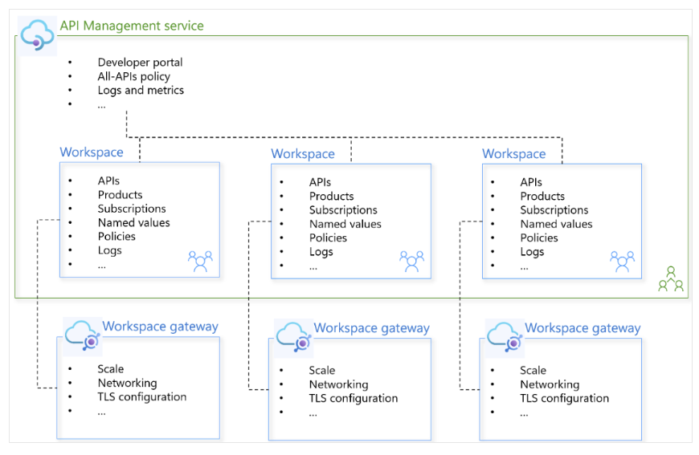

Workspace Features

APIM workspaces provide the following features:
- Each workspace contains APIs, products, subscriptions and related resources.

- Access to resources within a workspace is managed through Azure's role-based access control (RBAC) with built-in or custom roles assignable to Microsoft Entra accounts and scoped to a workspace.

- Each workspace is associated with one or more workspace gateways for routing API traffic to the backend services of APIs in the workspace.

- The Core Platform team can apply policies spanning APIs and products hosted within workspaces, to govern API runtime across the organisation. A built-in Azure Policy definition provides a mechanism for enforcing compliance across all workspace resources.

- Each development team’s access can be scoped to specific APIM workspaces allowing developers to gather gateway logs and monitor metrics pertaining to their own specific workspace APIs. The Core Platform team will have federated access to logs across all workspaces in the API Management service, providing oversight, security, and compliance across daa’s entire API estate.

Workspace Gateways
Each workspace is configured with one or more workspace gateways to enable runtime of APIs managed within the workspace. A workspace gateway is a standalone Azure resource providing the same core functionality as the API Management gateway itself.
Workspace gateways are managed independently from the API Management service and from each other. They facilitate independent runtime between workspaces, increasing API reliability, resiliency, and security.
Azure API Management uses a many-to-many relationship model between workspaces and workspace gateways. Workspaces can be associated with multiple gateways and similarly, gateways can be associated with multiple workspaces. For the purposes of this PoC, and in order to simply the relationship, a 1-to-1 mapping between workspaces and workspace gateways will be adopted.
- Workspace gateways are configured with specific compute configurations including Virtual Network integration, scale, specific hostnames and autoscaling functionality.
- At the time of writing, custom hostnames are not supported for workspace gateways. If custom hostnames are required, an appliance will need to be deployed ‘in-front’ of the workspace gateway to facilitate this e.g. an Azure Application Gateway or Azure Front Door instance.
- Configuration and computing resources are shared by all workspaces on a workspace gateway. To mitigate the risk of resource contention (where one workspace's heavy load impacts the performance of others), we recommend a 1-to-1 mapping between each workspace and its own dedicated workspace gateway.

Workspace Gateway Constraints
The following table contains a non-exhaustive list of the most relevant constraints with respect to APIM workspace gateways:

Limitation | Mitigation
A workspace can't be associated with a self-hosted gateway | Team or Product specific self-hosted gateways will be deployed where necessary where each team will be assigned an RBAC role against their relevant gateway. Further RBAC roles will also need to be assigned to individual APIs also to limit visibility and access (within the Azure portal) across teams.
Workspace gateways don't support inbound private endpoints | Ingress traffic will be initially processed by a public facing Application Gateway before then being privately routed to the Workspace Gateway’s private IP, obtained from the subnet specified when creating the gateway.
APIs in workspace gateways can't be assigned custom hostnames | The Application Gateway’s backend settings will leverage the Workspace Gateway’s FQDN, to route incoming traffic. A private DNS hosted zone is required to facilitate this name resolution.
APIs in workspaces aren't covered by Defender for APIs | Since the Application Gateway will process all API requests initially, a Web Application Firewall policy will be configured on each API listener to help protect APIs from various OWASP top 10 web attacks.
Workspace gateways don't support creating APIs directly from Azure resources such as Azure OpenAI Service, App Service, Function Apps. | APIs will be imported by targeting an OpenAPI (Swagger) definition URL.
Request metrics can't be split by workspace in Azure Monitor; all workspace metrics are aggregated at the service level | Configure a WorkspaceID property in the metadata for granular KQL filtering in Log Analytics.

Authorization

APIM facilitates OAuth by running the validate-jwt policy against the inbound processing stage. This policy acts as a security gate, verifying the integrity and validity of the Access Token before the request is allowed to proceed to the backend APIs/services i.e. those services hosted on the Market Place Azure Container App environment.

This validate-jwt policy is configured to perform several critical OAuth enforcement steps:
- Signature Verification - APIM automatically fetches the public signing keys from the IdP (B2C) via the well-known OpenID Configuration Endpoint. It uses these keys to cryptographically verify the token's signature, ensuring the token hasn't been tampered with.
- Issuer Check - APIM verifies that the token was issued by a trusted source i.e. daa’s B2C tenant.
- Audience Check - It ensures the token received as part of the inbound request is intended for the specific recipient/target i.e. the API being exposed
- Scope Check - It verifies that the token contains the necessary scopes or roles to perform the requested action e.g. checking for the order.write scope for a POST request.

The table below describes the core OAuth components contextualised to an APIM and Azure B2C implementation.
OAuth Role | Azure Service | Function in the Flow
Authorization Server | Azure AD B2C | The central authority (Identity Provider) that authenticates end-users and issues Access Tokens (JWTs).
Resource Server | Azure API Management (APIM) / Backend API | APIM is the primary enforcement point that validates Access Tokens; the backend API trusts APIM's validation.
Access Token (JWT) | Issued by AD B2C | The security credential the client presents to APIM. It contains cryptographically signed claims proving the user was successfully authenticated by B2C and what permissions they have.  Passed in the Authorization: Bearer header of every API request.
Client | Web App / Mobile App | The application that acquires the token and sends it with the request.
Audience (aud claim) | The API’s Application ID i.e. B2C App Registration | Identifies the intended recipient of the token. APIM strictly checks this claim to ensure the token was issued for your API, preventing tokens from being misused on unintended services.  Must be defined in the <audiences> tag of the APIM validate-jwt policy.
Issuer (iss clain) | B2C Tenant & Policy URL | Identifies who issued the token (i.e., daa’s specific B2C tenant). APIM checks this to ensure the token didn't come from a malicious or unauthorized identity provider.  Must be defined in the <issuers> tag of the APIM validate-jwt policy.
OIDC Well-Known URL | B2C Policy Metadata Endpoint | This is a public metadata endpoint where APIM finds all necessary security information e.g. the public signing keys (JWKS). APIM uses these keys to cryptographically verify the token's signature, ensuring it hasn't been tampered with.  Defined in the <openid-config url="..."> tag of the APIM validate-jwt policy.
Scope (scp claim) | B2C API App Registration Scopes (e.g., read, write) | Identifies the permissions the user was granted by B2C for this specific API. APIM can be configured to reject the request if the token doesn't contain the minimum required scopes for that operation.  Defined in the <required-claims> tag of the APIM validate-jwt policy.
Subject (sub claim) | B2C User Unique Identifier | Identifies the validated user. This immutable unique ID is critical for the backend to perform user-specific operations (e.g., fetching a user's specific bookings).  This is the value that APIM extracts and injects into the X-User-ID header before forwarding the request to the Backend API service.
Resource Owner | Azure AD B2C User Account | The entity that owns the protected data/resources and grants the Client (Web App) permission to access them. This is the end-user account stored in the B2C tenant that is logging in.

APIM Authorization Code Flow - Diagram
The diagram below illustrates the proposed authorisation code flow once APIM has been deployed. The sequence of steps illustrated assume the user has already successfully authenticated i.e. the access token is already available in the browser’s storage. The introduction of APIM should not impact the existing authentication mechanism.

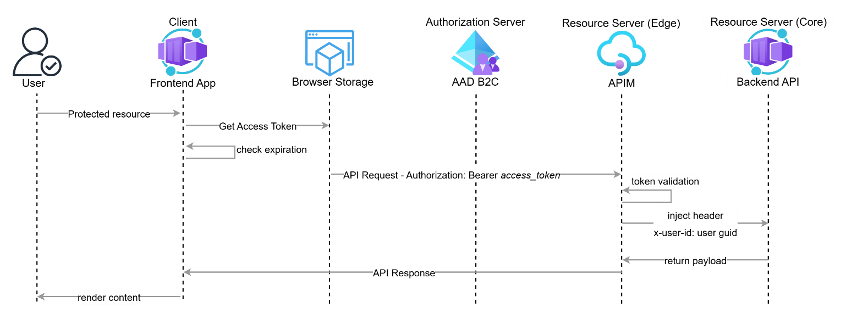

The sequence of steps listed below describes an end-to-end authorization code flow contextualised to the introduction of APIM.

Authorization Code Flow – Token Refresh

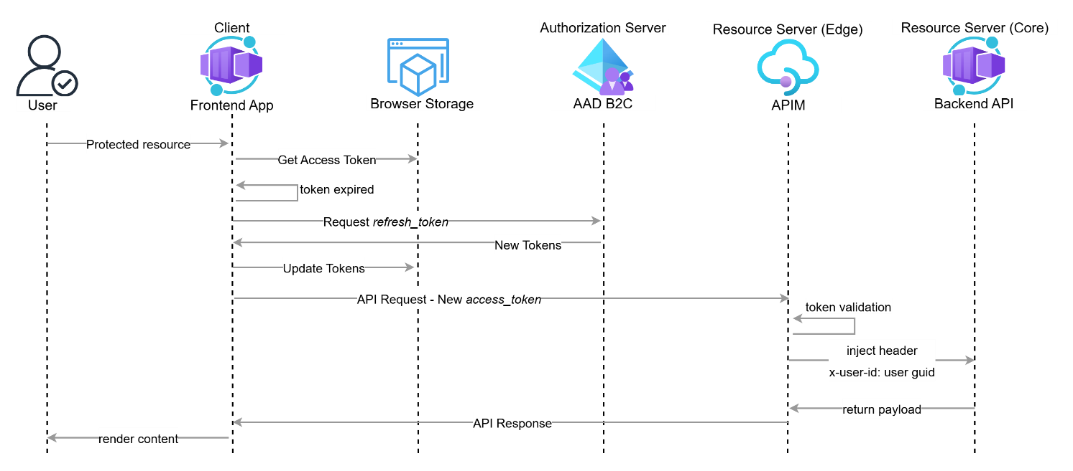

APIM Authorization Code Flow - Sequence

- Authorization Request: The User attempts to sign in. The frontend (Client) redirects the browser to AD B2C (Authorization Server) SUSI policy endpoint. This request includes the Client ID (the Web or Mobile GUID) and a code_challenge (PKCE).
- User Authentication: The User provides credentials. Azure AD B2C validates the identity and redirects the browser back to the frontend with an Authorization Code.
- Token Exchange: The frontend sends the Authorization Code and the code_verifier to the B2C /token endpoint. Azure AD B2C returns a JSON response containing three distinct tokens:
- ID Token: A JWT intended only for the frontend (Client) to help personalise the UI for the user after logging in
- Access token: A JWT intended only for the APIM (Resource Server). It contains the permissions (Scopes) and the user’s unique identifier (Subject).
- Refresh token: A long-lived string used to obtain new tokens without re-authenticating the user.
- UI Hydration: The Frontend decodes the ID Token locally and extracts claims e.g. name, email etc.
- Protected Resource Access: The User attempts to navigate to a protected route via the frontend.
- Token Validation (Client-Side): The frontend retrieves the user's Access Token (JWT) from the browser’s local storage and checks its expiration time.
- If expired, the frontend sends a Refresh Request (using the refresh_token) to the Azure AD B2C /token endpoint to get a new Access Token.
- If valid, the frontend sends an API Request containing the Access Token in the Authorization: Bearer HTTP header to APIM.
- Token Validation (Resource Server): APIM executes the validate-jwt policy against the incoming request, performing security checks on the Access Token:
- Signature: Verification using Public Signing Keys retrieved from the AD B2C OIDC metadata endpoint (JWKS).
- Claims: APIM will extract the Issuer (iss) and Audience (aud) claims. The aud value must match either the Web App Registration GUID or the Mobile App Registration GUID. Since the Market Place uses separate app registrations for Web and Mobile access, both GUIDs need to be defined in the APIM policy.
- Authorization: APIM will extract the Scope (scp) claim and validate it against the required permissions for the requested endpoint.
- Identity Propagation: Upon successful validation, APIM extracts the validated user’s identity (e.g., the sub claim) from the Access Token. This value represents the user’s unique Azure AD B2C GUID. APIM injects this into a custom HTTP header: x-user-id.
- Request Forwarding: APIM forwards the request (now stripped of the Access Token and containing the x-user-id header) to the Backend API service, bypassing the BFF service completely.
- The Backend API service receives the request, trusts the injected header (no need for JWT validation), performs its business logic and prepares the final payload.
- The Backend API service sends the resulting data payload back to APIM. APIM forwards the payload as the final API Response to the Frontend App. The Frontend App uses the received data to render the final protected content to the User.

ADB2C integration
The APIM instance trusts AD B2C by way of an APIM policy. This policy can be configured at the global level, a workspace level, product level etc. However, to ensure consistency and to align with best practice, this policy should be defined in an APIM Policy Fragment (a reusable snippet) at the Global (Service) level, and then referenced in your APIM Workspaces or Product policies.

To successfully validate incoming JWTs, the APIM API must reference the policy specific AD B2C tenant’s OpenID Connect (OIDC) Metadata endpoint associated with the B2C User Flow used for authentication (e.g. the sign-up-sign-in policy).

It’s important to note that unlike Entra ID, in AD B2C, the metadata endpoint is policy-specific.The AD B2C policy needs to be defined in this endpoint otherwise APIM won't know which specific keys or issuer to look for.

APIM uses this endpoint to download the Public Signing Keys. When a request arrives with a token, APIM uses these public keys to verify the token's digital signature. If the signature matches, APIM knows the token was issued by the AD B2C tenant defined in the policy and hasn't been tampered with.

Identity Propagation – Authenticated Users
In the current architecture, the BFF service is responsible for parsing and validating raw JSON Web Tokens (JWTs) to establish user identity. With the introduction of APIM as the centralised security gateway, this responsibility is shifted upstream to the infrastructure layer.
By offloading JWT validation to APIM, we achieve the following benefits:
- Backend services no longer need to parse complex OAuth 2.0 tokens or manage signing keys. They simply consume a trusted, plain-text header.
- Cryptographic/signature validation is CPU-intensive. Performing this once at the gateway prevents redundant processing across multiple downstream services.

With the introduction of API, all incoming requests containing a valid Bearer token will be injected with a custom HTTP header (X-User-ID) before being forwarded to the backend service. The value used to populate this header is extracted directly from the sub (Subject) claim of the validated JWT. The value will be a standard GUID and serves as the unique identifier for the user within the Azure AD B2C directory.
The backend services must be configured to trust this header only when the request originates from APIM. The presence of this header implies that the user has been fully authenticated and the token's integrity has been cryptographically verified by APIM.

Integration Considerations

Application Gateway Integration

When the Application Gateway forwards an incoming API request to an APIM workspace gateway, it adds (or updates) the X-Forwarded-For header. This header contains the original client's public IP address. APIM is smart enough to inspect the X-Forwarded-For header to correctly extract the true, external client's Public IP address. This can then be used within an APIM Policy by using the following variable: context.Request.IpAddress. This is particularly relevant for implementing throttling against unauthenticated users.

Container Apps Integration

Integrating Azure API Management (APIM) directly with a Market Place backend API, hosted on Container Apps, provides the ability to offload JWT validation from the existing BFF service to APIM. Because of this, traffic from APIM can bypass the BFF service (where JWT validation is currently executed) and directly target a Market Place backend API. However, this approach will likely necessitate a refactor of the existing logic on the backend API.
To ensure the backend APIs still know the caller's identity, APIM's policy must be configured to inject trusted identity headers after successful JWT validation. For example, the X-User-ID, whose value APIM extracts from the validated token's Subject (sub) claim.
Other valuable injected headers include X-User-Scopes (listing granted permissions). The backend service's code must be refactored to trust and consume these injected headers for its internal authorization and business logic, rather than processing the raw Authorization header.

APIM Policy

APIM Policies are a powerful, structured mechanism for changing the behavior of an API through configuration which can be applied at various scopes to enforce consistent governance. These policies are executed in a processing pipeline, with scopes ranging hierarchically from the broadest Global (Service Level), which affects all APIs, down to the Workspace level (for specific teams/environments) and the Product level. Common examples include security policies e.g. the validate-jwt policy for token verification, rate-limit-by-key for throttling, and set-header for manipulating request and response data.

The diagram below illustrates the various scopes that policies can be applied against.

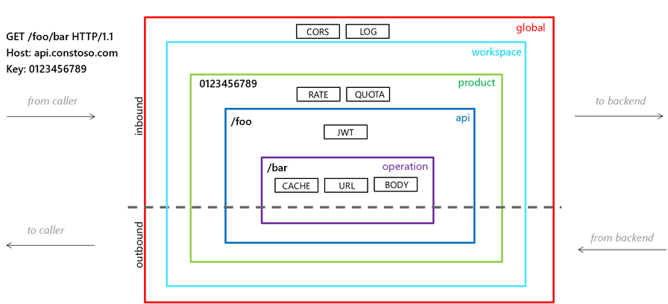

APIM Policies

The table below captures a non-exhaustive list of APIM policies. For a full list of APIM native policy examples, see here
Policy | Description
Limit call rate by key | Prevents API usage spikes by limiting call rate, on a per key basis.
Set usage quota by key | Allows you to enforce a renewable or lifetime call volume and/or bandwidth quota, on a per key basis.
Check HTTP header | Enforces existence and/or value of an HTTP header.
Get authorization context | Gets the authorization context of a specified connection to a credential provider configured in the API Management instance.
Restrict caller IPs | Filters (allows/denies) calls from specific IP addresses and/or address ranges.
Validate Microsoft Entra token | Enforces existence and validity of a Microsoft Entra (formerly called Azure Active Directory) JWT extracted from either a specified HTTP header, query parameter, or token value.
Validate JWT | Enforces existence and validity of a JWT extracted from either a specified HTTP header, query parameter, or token value.
Validate parameters | Validates the request header, query, or path parameters against the API schema.
Validate headers | Validates the response headers against the API schema.
Validate status code | Validates the HTTP status codes in responses against the API schema.

APIM Policy Example

<policies>
<policies>
<inbound>
<base />

<cors allow-credentials="true">
<allowed-origins>
<origin>https://your-frontend-app.com</origin>
</allowed-origins>
<allowed-methods>
<method>GET</method>
<method>POST</method>
</allowed-methods>
<allowed-headers>
<header>*</header>
</allowed-headers>
</cors>

<choose>
<when condition="@(context.Request.Headers.GetValueOrDefault("Authorization","").StartsWith("Bearer "))">

<validate-jwt header-name="Authorization" failed-validation-httpcode="401" output-token-variable-name="jwtToken">

<openid-config url="https://<TENANT_NAME>.b2clogin.com/<TENANT_NAME>.onmicrosoft.com/B2c_policy/v2.0/.well-known/openid-configuration" />

<audiences>
<audience>00000000-0000-0000-0000-000000000000</audience>
</audiences>

<issuers>
<issuer>https://<TENANT_NAME>.b2clogin.com/<TENANT_ID>/v2.0/</issuer>
</issuers>
</validate-jwt>

<set-header name="X-User-ID" exists-action="override">
<value>@(context.Variables.GetValueOrDefault<System.IdentityModel.Tokens.Jwt.JwtSecurityToken>("jwtToken")?.Claims.FirstOrDefault(c => c.Type == "sub")?.Value)</value>
</set-header>
<set-header name="X-Auth-Status" exists-action="override">
<value>AUTHENTICATED</value>
</set-header>

<rate-limit-by-key calls="1000" renewal-period="60"
counter-key="@(context.Variables.GetValueOrDefault<System.IdentityModel.Tokens.Jwt.JwtSecurityToken>("jwtToken")?.Subject)" />
</when>

<otherwise>
<set-header name="X-User-ID" exists-action="delete" />
<set-header name="X-Auth-Status" exists-action="override">
<value>GUEST</value>
</set-header>

<rate-limit-by-key calls="10" renewal-period="60"
counter-key="@(context.Request.IpAddress)" />
</otherwise>
</choose>

</inbound>
<backend>
<forward-request />
</backend>
<outbound>
<base />
</outbound>
</policies>

Key Policy Parameters
The table below listed the key parameters that are required to populate the jwt-validation policy,
Role | Description
OpenID Configuration URL | Used to specify a compliant OpenID configuration endpoint URL from which signing keys and issuer can be obtained which are used to verify the access token’s signature.  Configuration including the JSON Web Key Set (JWKS) is pulled from the endpoint every 1 hour and cached. If the token being validated references a validation key (using kid claim) that is missing in cached configuration, or if retrieval fails, API Management pulls from the endpoint at most once per 5 min. These intervals are subject to change without notice.  It is a dynamic URL formatted as https://<tenant_name>.b2clogin.com/  <tenant_name>.onmicrosoft.com/<B2C_policy_name>/v2.0/.well-known/openid-configuration.
Audience (aud) | A list of acceptable audience claims, in audience subelements, that can be present on the token. If multiple audience values are present, then each value is tried until either all are exhausted (in which case validation fails) or until one succeeds. At least one audience must be specified.  The aud claim extracted from the incoming Access Token must exactly match the Application (Resource Server) ID (GUID) of the App Registration. Note, since Market Place uses a single Application Registration for both the client and the resource server, the aud claim value will be the same for the ID Token and the Access Token.
Issuer (iss) | A list of acceptable principals, in issuer subelements, that issued the token. If multiple issuer values are present, then each value is tried until either all are exhausted (in which case validation fails) or until one succeeds.  The unique identifier of the AD B2C tenant. It must match the iss claim inside the access token exactly — usually formatted as https://<tenant_name>.b2clogin.com/<tenant_id>/v2.0/.
Policy Name | The specific B2C User Flow name (e.g., B2C_1_susi). This is mandatory because in B2C, security keys are tied to the specific user journey that issued the token.  Every B2C policy has a unique metadata endpoint. If you use the wrong policy name in your OIDC URL, APIM will try to verify the token using the wrong cryptographic keys.

IAM
APIM provides built-in roles specifically designed for managing access within a Workspace, separate from full control over the entire APIM instance. However, to grant access to a workspace, a user typically needs a combination of two roles assigned at different scopes.
These roles are described in the table below
Role | Scope | Description
API Management Workspace Reader | APIM Workspace | Has read-only access to all entities (APIs, products, etc.) within that specific workspace. This is the most restrictive built-in role for viewing the workspace resources.
API Management Workspace Contributor | APIM Workspace | Can manage the workspace and its entities (create, modify APIs, products, etc.) but cannot modify its members.
API Management Workspace API Developer | APIM Workspace | Focuses on read/write access for editing APIs in the workspace.
API Management Workspace API Product Manager | APIM Workspace | Focuses on read/write access for publishing APIs in the workspace.

In addition to the workspace-scoped roles above, a user needs a corresponding service-scoped role assigned at the API Management Service instance level. This is required to enable the necessary read access to certain shared, service-level resources that workspace resources may reference (e.g. global policies, named values), and often to allow the user to see the APIM instance in the portal and navigate to the target workspace.

Role | Scope | Description
API Management Service Workspace API Developer | APIM Service | Allows read access to tags and products and write access to assign APIs/tags to products.
API Management Service Workspace API Product Manager | APIM Service | Similar to the Developer role, but also has read access to users and can assign users to groups.

For the purposes of the PoC and for future development, the Cloud Platform team should be responsible for assigning the appropriate roles to Market Place developers to align with a least privilege model. An exercise in mapping out the Azure native roles to equivalent daa roles is warranted to ensure a smooth onboarding process.

Virtual Network Integration

When deploying an APIM instance within a Virtual Network, there are two types of integration methods available. To ensure the APIM instance and the workspace gateway are accessible from within Azure only, Virtual Network injection is the recommended configuration. Both options are described below.

Virtual Network Injection (VNet Injection)
VNet Injection is the option for complete network isolation of the API Management service.
- Inbound Traffic - The APIM Gateway endpoint is accessible only via a private IP address within the Virtual Network (VNet). The service is completely isolated from the public internet.
- Outbound Traffic - The APIM service uses a private IP from the VNet subnet for all outbound connections, allowing it to securely connect to private, network-isolated backends within the VNet, peered networks, or on-premises networks (via VPN/ExpressRoute).

Virtual Network Integration (VNet Integration)
VNet Integration is the option for securing outbound traffic only, while keeping the APIM endpoints publicly accessible.nnbbnnbn
- Inbound Traffic - The APIM Gateway, Developer Portal, and Management Plane endpoints remain publicly accessible via a public IP address.
- Outbound Traffic - The APIM service uses a private IP from the VNet subnet for outbound connections, allowing it to connect to private, network-isolated backends within the VNet or peered networks.

DNS

Public DNS

Record Name | Domain | Resolution
apim-poc | dublinairport.com | Non-production Application Gateway

Private DNS

Record Name | Domain | Resolution
Runtime hostname of APIM workspace gateway. | azure-api.net | Private IP of APIM’s workspace gateway. Value know only after deployment.

HIGH AVAILABILITY
There are two methods to configure high availability for APIM gateways. These methods are configurable when deploying the APIM instance itself, not when deploying the APIM workspace i.e. the Workspace Gateway automatically inherits the zone configuration from the parent APIM resource.
API Management service tiers provide different levels of reliability. This document focuses on the Premium (Classic) service tier (to avail of Workspaces within Azure’s North Europe region where daa’s Azure services are deployed), which supports multiple units that can be distributed across availability zones for maximum resilience. In the Premium tier, each unit consists of two virtual machines (VMs) that provide the compute resources to handle API requests.

NOTE: When self-hosted gateways are deployed, daa are responsible for configuring them to satisfy high availability requirements e.g. by deploying two instances across AZs/fault domains.

Automatic availability zone support
If ‘Automatic’ is selected when deploying the APIM (parent) instance, API Management makes a best-effort attempt to spread the gateway’s units among the region's availability zones as illustrated below.
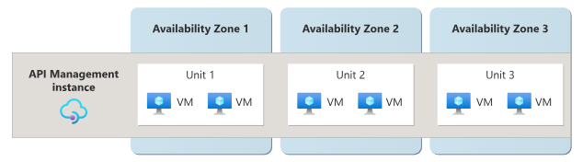
If a gateway is configured with a single unit only, the unit's underlying VMs are distributed to two availability zones as illustrated below.
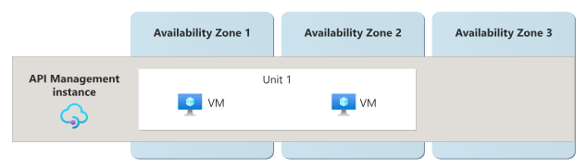

Whether multiunit or single-unit configuration, there's no way to determine which availability zones the gateway unit's VMs are placed into.

Manual availability zone support
When creating the APIM instance, select two or more availability zones to use. With this approach, Azure automatically replicates the gateway’s units across the selected zones as illustrated below.
It is recommended to manually configure the APIM Availability Zones to align with daa’s existing Application Gateway Availability Zone configuration to ensure the same zones are leveraged at both tiers. For example, if the Application Gateway is configured to span AZ1 and Az2, the APIM instance should mirror this.



Considerations

Compute Isolation: Deploying environment specific workspace gateways decouples the compute layer e.g. the CPU, Memory, or Network throughput, from each environment. If a deployment to the Dev/Test workspace gateway hangs or crashes, the Production workspace gateway will continue to process traffic.
Control Plane vs. Data Plane: To ensure high availability (HA) in a federated APIM model, it is important to distinguish between the Data Plane and the Control Plane.
- While all workspaces share a central management interface, Azure physically separates the Data Plane (gateway traffic) by way or workspace gateways. A failure or resource exhaustion in a non-production unit (Dev/Test) is logically isolated and cannot contaminate/impact the Production gateway’s traffic.

- However, increasing gateway units within a single instance (from 1 to 2) only provides traffic redundancy; it does not mitigate Control Plane locks. Certain high-level changes e.g. updating global security policies or networking, place the entire APIM service into a "Transitioning" state. During this state, a lock is applied at the Resource ID level. If a deployment against an APIM global configuration causes the service to hang or transition slowly, it temporarily freezes the management plane for all workspace. This can, for example, inhibit a development team from importing new Swagger files or making any configuration updates to Production until the transition completes.

DevOps & Operating Model

Terraform Providers
Since the existing Azure services deployed to the Connectivity Subscription are all managed via HashiCorp’s Infrastructure as Code tool, Terraform, we recommend continuing to leverage this tool when building ot the Azure APIM services.
However, please note, the current versions of the Terraform’s AzureRM provider does not natively support Workspace Gateways e.g. by way of a azurerm_api_management_workspace_gateway resource. While the provider supports the top-level Workspace resource, the sub-resource for gateways within those workspaces hasn't been implemented yet.
The industry-standard alternative for this scenario is the AzAPI Provider. This provider acts as a thin layer over the Azure ARM APIs, allowing you to manage resources that are in preview or missing from the standard azurerm provider without leaving your Terraform workflow.
Further detail on this provider can be found here: azapi_resource | Resources | Azure/azapi | Terraform | Terraform Registry

AzAPI Provider Example
The code snippet below provides a high-level example of how to leverage both the standard azurerm provider and the azapi provider to address the shortcoming described above.

provider "azurerm" { features {} }
provider "azapi" {}

# 1. Create the Premium APIM Instance (Required for Workspaces)
resource "azurerm_api_management" "apim" {
name = "apim-service-poc"
location = "North Europe"
resource_group_name = "api-rg"
publisher_name = "daa"
publisher_email = "admin@daa.com"
sku_name = "Premium"
}

# 2. Create the Workspace
resource "azurerm_api_management_workspace" "poc" {
name = "poc-workspace"
api_management_id = azurerm_api_management.apim.id
display_name = "Market Place PoC"
}

# 3. Deploy multiple Workspace Gateways using AzAPI
locals {
gateways = {
"marketplace-gw-dev " = "mp-dev"
" marketplace-gw-tst" = "mp-tst"
}
}

resource "azapi_resource" "workspace_gateways" {
for_each = local.gateways
type = "Microsoft.ApiManagement/service/workspaces/gateways@2023-09-01-preview"
name = each.key
parent_id = azurerm_api_management_workspace.engineering.id

body = {
properties = {
description = each.value
locationData = {
name = "East US"
}
}
}
}

RACI Matrix

To establish a clear and efficient operating model for the federated APIM implementation, it is essential to define the boundaries between infrastructure management, centralised governance, and decentralised development. The following RACI table outlines a non-exhaustive list of common APIM lifecycle tasks and administrative requirements. This framework is designed to empower the backend development team (the Market Place team for the PoC) with autonomy in their workspace, while ensuring the Integrations Team instils standardisation and the Cloud Platform Team provides a secure, high-availability network foundation.

Task | Cloud Platform | Integrations | Dev Team
APIM Service & Network Setup | A / R | C | I
Workspace Creation | R | A | I
Workspace Gateway Deployment | A / R | C | I
Global Policies (JWT, CORS, Global Logging) | I | A / R | C
Swagger Management/Import | I | C | A / R
Naming Standards & Workspace IAM | R | A | C
Product & Subscription Management | I | A | R
Application Gateway Config | A / R | C | I
Certificate / Secret Management | A / R | C | I
Developer portal | I | A/R | C

DEPLOYMENT PATTERNS BY TEAM

This section captures a high-level overview of the proposed deployment patterns with respect to daa’s internal teams who will operate and manage the APIM services, specifically the Cloud Platform team, Integrations team and backend development team(s).

Cloud Platform Team
The Cloud Platform Team is responsible for the deploying and configuring the APIM service’s foundations. Their deployment pattern focuses on core infrastructure components that provide the network security, residency, and administrative boundaries required for a federated model. They are responsible for creating and managing the following services:
- APIM Service Provisioning
- VNet & Subnet Management
- Workspaces & Workspace gateways
- Ingress Security - they are responsible for configuring the Azure Application Gateway and Web Application Firewall (WAF) that sit in front of the APIM instance to handle SSL termination and public-facing security rules
- Role assignments for Entra ID Groups scoped to specific workspaces (as requested from the Integrations team)

Given the criticality of the shared APIM instance across multiple projects and domain, a dedicated repo is recommended to manage this deployment. The diagram below illustrates the core services to be managed by the Cloud Platform team.
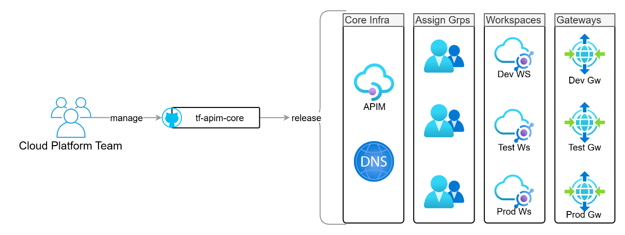

Integrations Team
The Integrations Team manages the enforcement of policies and best practices across the APIM service. Their deployment pattern focuses on enforcing organisational standards across all environments while enabling a consistent experience for API consumers (most pertinent to b2b customers).
They are responsible for creating and managing the following configurations
- Global Policy Enforcement e.g. JWT validation, logging, that all workspaces inherit.
- Responsible for the configuration and branding of the Developer Portal, ensuring consistent discovery and onboarding for internal and external consumers.
- Deploying shared Named Values (secrets) and Policy Fragments into individual Workspaces (Dev, Test, Prod) to provide backend teams with pre-approved standards for their APIs.
- Detail on TF setup for the Int Team?
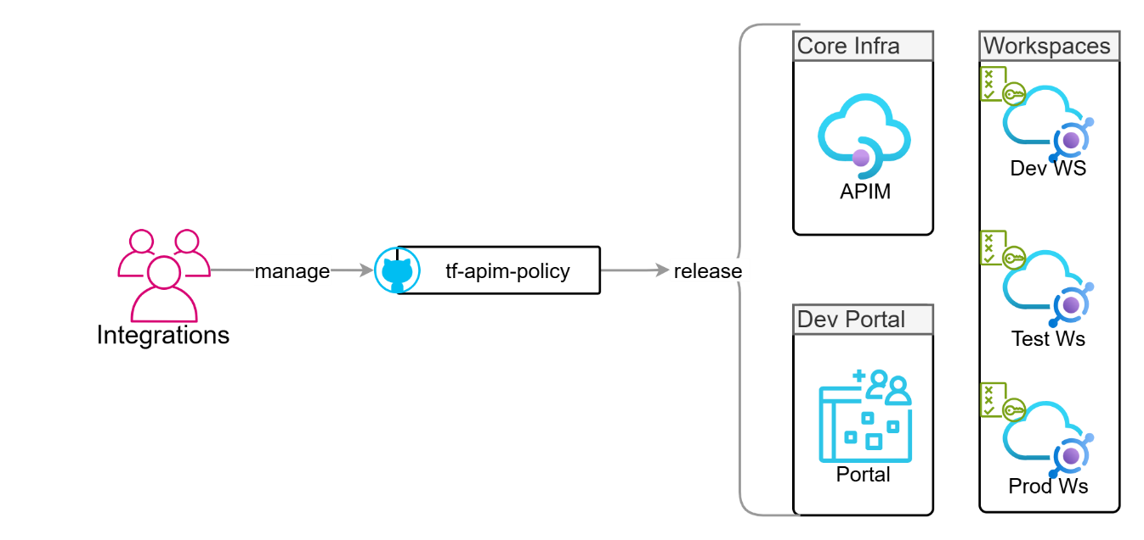

Backend Development Team
The backend development team’s deployment pattern follows a sequential, dependency-aware workflow that ensures the API contract (Swagger) always matches the running code. They are responsible for
- Deploying their services to ACA first. This stage includes health checks to ensure the container is running and the /swagger.json or /.well-known/openapi endpoint is reachable.
- Once ACA is healthy, the pipeline triggers a "Schema Import" to the APIM Workspace. Instead of writing complex Terraform for every endpoint, they use a simple "Import from URL" task (via CLI, PowerShell, or AzAPI).
- Within their assigned workspace, they are Responsible for mapping their APIs to the Products managing their specific API revisions.
- They ensure the Swagger file is the single source of truth. Any change in the backend code that affects the API must be reflected in the Swagger before the APIM update can succeed.

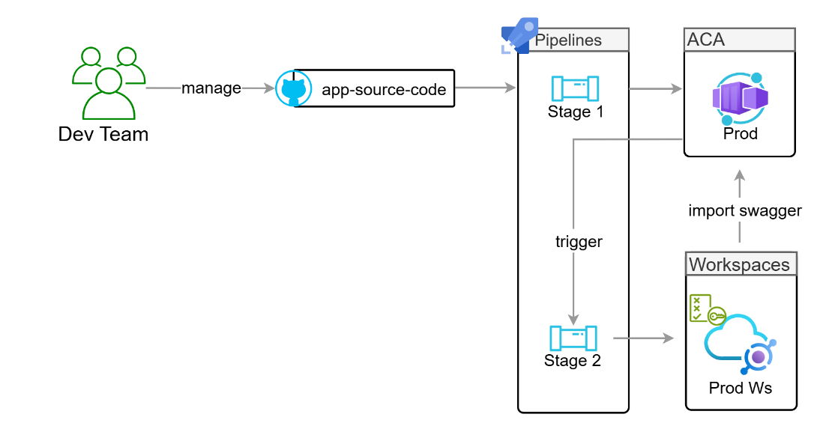

APIM Running Costs

The table below captures the monthly running costs for deploying an instance of APIM to Azure’s North Europe region.
These running costs are based on the following assumptions
- The Premium tier will be deployed to avail of workspaces

- A dedicated Production workspace gateway will be deployed configured with 2 units, one per AZ to facilitate HA

- A single, shared workspace gateway will be deployed to facilitate connectivity to the Dev and Test (Market Place) environments.

- The baseline fee of 2,375.43 per month is the cost of the APIM service itself. Even if we delete every gateway and API, as long as the resource exists in the Azure subscription, you are billed this amount for the management capabilities.

Service | Environment | Unit Count | Monthly Costs
APIM (parent) instance | All (non-prod shared) | 1 | 2,375.43
Workspace Gateway | Production (MP only) | 2 (1 / AZ) | 2,379.54
Workspace Gateway | Dev / Test (MP only) | 1 | 1,189.77
 |  | Total | 5,944.74

Note: At the time of writing, there is no official guidance on associating APIM’s default built-in gateway with a workspace. While a workspace cannot be created in the portal without associating it with a workspace gateway, a standalone workspace can be created programmatically (via the API or IaC) without having to associate a workspace gateway. This approach would need to be tested.
If the default built-in gateway can be associated with a workspace, it potentially negates the need to deploy a dedicated Dev/Test workspace gateway allowing daa to reduce the overall monthly sped by 1,189.77 euro.
See here fore more detail: Update To API Management Workspaces Breaking Changes: Built-in Gateway & Tiers Support | Microsoft Community Hub

Strategic Considerations

Move towards a two tier model

When you have two distinct App Registrations, Azure AD B2C differentiates the tokens based on the Scope requested:
- ID Token: Always has the Client App ID as the audience (aud). It is intended for the frontend to identify the user.
- Access Token: When the frontend requests a scope defined by the Resource Server (e.g., https://mytenant.onmicrosoft.com/api/read), B2C sets the Resource Server's App ID (or App ID URI) as the audience (aud).
The Rule: The aud claim in an Access Token represents the Resource the client is trying to access. Therefore, in your APIM policy, the aud check must look for the Resource Server's Application ID.

Appendix

Platform requirements
The following table captures the Azure platform resources and their recommended configuration that need to be deployed to facilitate the PoC.
Azure Service | Expansion
Subnets x2 | A new subnet is required to host the APIM instance itself. The minimum size of the subnet in which APIM can be deployed is /29, which provides three usable IP addresses. However, to account for future growth and in the event of this subnet being reused for a more strategic deployment (i.e. Production), a /27 is recommended.  A separate subnet is required to host the APIM Workspace Gateway. This subnet must be dedicated to the Workspace Gateway. It cannot be mixed with other resources. While Microsoft recommends a /24 subnet to account for scaling the gateway, a /27 subnet should suffice for the PoC. This subnet will be deployed to the Connectivity virtual Network.
Private DNS Zone | A new private DNS Zone – azure-api.net - needs to be created in the Connectivity subscription and linked to the Connectivity Virtual Network. This zone will host the record for the APIM workspace gateway’s runtime hostname DNS allowing the Application Gateway to resolve its DNS to a private IP.
Azure DevOps Repository | For the purposes of the PoC, a dedicated, isolated ADO repository is recommended to avoid disrupting the Application Gateway repository. Once the code has been validated and assuming a positive outcome from the PoC, the APIM code can then be moved to the Application Gateway repo if desired.
Workspace Gateway | The AP|IM workspace gateway should be configured with Virtual Network injection to ensure the gateway’s runtime hostname is only accessible from within Azure.
Application Gateway Configuration | A new listener, backend pool, health probe and routing rule is required to publicly surface the APIs that are being tested as part of this PoC. As described earlier in the document, the suggested sub-domain is apim-poc.dublinairport.com.

RACI Definitions

The table below provides a definition for each of the RACI roles.
Role | Meaning | Description | Example Resource
R | Responsible | The "Doer." This team or individual performs the actual work to complete the task. | Engineer/Developer
A | Accountable | The "Owner." This person has the final authority and must sign off on the work. Only one team/person can be accountable. | Architect/Team Lead
C | Consulted | The "Advisor." These are subject matter experts whose opinions are sought before or during the task. It is a two-way communication. | SME
I | Informed | The "Recipient." These stakeholders are kept up to date on progress or completion. It is a one-way communication. | Interested party / Consumer

Glossary of Terms

Abbreviation | Expansion
IaC | Infrastructure as Code
Vnet | Virtual Network
APIM | Azure API Management


For more information,
please visit version1.com
Thank you

